**Alarm System**

By: Khaled AL Swayed

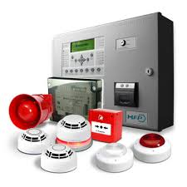

An alarm system is a system designed to detect intrusion – unauthorized entry – into a building or other area such as a home or school. Security alarms are used in residential, commercial, industrial, and military properties for protection against burglary theft or property damage, as well as personal protection against intruders. Security alarms in residential areas show a correlation with decreased theft. Car alarms likewise help protect vehicles and their contents. Prisons also use security systems for control of inmates.

Some alarm systems serve a single purpose of burglary protection; combination systems provide both fire and intrusion protection. Intrusion alarm systems may also be combined with closed-circuit television surveillance (CCTV) systems to automatically record the activities of intruders and may interface to access control systems for electrically locked doors. Systems range from small, self-contained noisemakers, to complicated, multirally systems with computer monitoring and control. It may even include two-way voice which allows communication between the panel and Monitoring station.

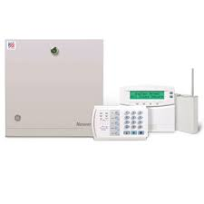The most basic alarm consists of one or more sensors to detect intruders, and an alerting device to indicate the intrusion. An alarm system has several important components, and the most important component is the control panel, which is the brain of the system, it reads sensor inputs, tracks arm/disarm status, and signals intrusions. In a modern system, this is typically one or more computer circuit boards inside a metal enclosure, along with a power supply. Many newer systems often use sealed plastic boxes out in the open. Some also have their control units built-in to the keypad or other human-machine interface.

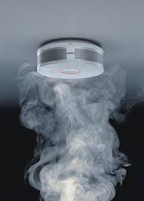A control room also consists of a lot of sensors which is the devices which detect intrusions. Sensors may be placed at the perimeter of the protected area, within it, or both.

Sensors can detect intruders by a variety of methods, such as monitoring doors and windows for opening, or by monitoring unoccupied interiors for motions, sound, vibration, or other disturbances and the most important of them all is the smoke sensor which is a device that senses smoke, typically as an indicator of fire and it can be connected in a parallel circuit.

Sirens is also needed in an alarm system which is the sound system in an alarm system which alerts the alarm condition, or it can be detected by LED lights.

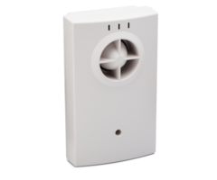

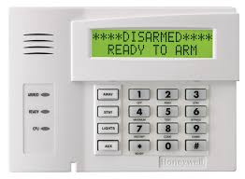Keypads is one of the most important components of an alarm system which is a small device, typically wall-mounted, which function as the human-machine interface to the system. In addition to buttons, keypads typically feature indicator lights, a small multi-character display, or both.

Interconnections between components. This may consist of direct wiring to the control unit, or wireless links with local power supplies.

There is a lot of sensors in the alarm system like the door sensor, vibration sensor, glass break sensor, motion detector, and smoke detector each we are going to talk about.

A Door sensor is a peripheral security sensor that lets an alarm system know whether a door is opened or closed. When a door is opened, the sensor will activate and let the system know about the situation. The system will then respond based on the programming settings for that zone. Most door contacts operate in a relatively similar manner. They usually consist of two parts - a sensor and a magnet. The sensor is considered more valuable, and certain measures are taken to protect it from damage.

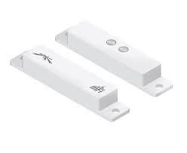

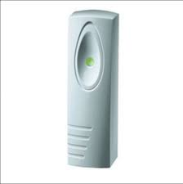A Vibration senor are sensors for measuring, displaying, and analyzing linear velocity, displacement and proximity, or acceleration, however subtle and unnoticed by human senses is a telltale sign of machine condition. Abnormal vibration indicative of problems with an industrial machine can be detected early and repaired before the event of machine failure; because such a failure is potentially costly in terms of time, cost, and productivity, vibration measurement allows industrial plants to increase efficiency and save money. Therefore, vibration analysis is used as a tool to determine equipment condition as well as the specific location and type of problems.

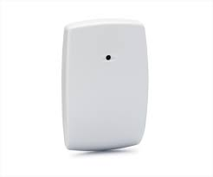A Glass break sensor is a sensor used in electronic burglar alarms that detects if a pane of glass is shattered or broken. These sensors are commonly used near glass doors or glass store-front windows. Glass break sensors usually use a microphone, which monitors any noise or vibrations coming from the glass. If the vibrations exceed a certain threshold, they are analyzed by detector circuitry.

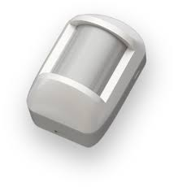A Motion detector is the device that utilizes a sensor to detect nearby motion. Such a device is often integrated as a component of a system that automatically performs a task or alerts a user of motion in an area. They form a vital component of security, automated lighting control, home control, energy efficiency, and other useful systems.

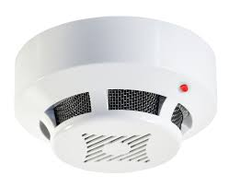A Smoke detector is a device that senses smoke, typically as an indicator of fire. Commercial smoke detectors issue a signal to a fire alarm control panel as part of a fire alarm system, while household smoke detectors, also known as smoke alarms, generally issue an audible or visual alarm from the detector itself or several detectors if there are multiple smoke detectors interlinked.

Finally, an alarm system has to have a way to control it or maintain it and we can do that by using access control which is the selective restriction of access to a place or other resource while access management describes the process. The act of *accessing* may mean consuming, entering, or using. Permission to access a resource is called authorization.

**References**

**www.alarmgrid.com**

**www.globalspec.com**

**en.wikipedia.org**